241/1
History and
Political education
Paper 1
2024
1 hour 40 mins

BSR JOINT MOCK EXAMINATIONS – 2024

UGANDA CERTIFICATE OF EDUCATION

HISTORY AND POLITICAL EDUCATION

Paper 1

2 HOURS 15 MINUTES

INSTRUCTIONS TO CANDIDATES:

This paper consists of sections A and B. It has four examination items

Section A is compulsory

Answer one item from section B

Answer three examination items in all
three items.

Any additional item answered will not be scored.

All responses must be written in the answer sheet(s) provided.

Turn Over
SECTION A
Answer all items in this section
- Nakulabye, a Kampala suburb, is overwhelmed by refugees from Eritrea, Ethiopia, Rwanda, and Burundi. The natives are frustrated by their presence and demand government action. Since Uganda is part of the East African Community, the government cannot restrict refugee entry. The President has tasked the Resident District Commissioner (R.D.C) to organise a workshop to convince the natives to accept the refugees. However, the Commissioner is unsure what to discuss with the community. He is worried that his communication may just increase tension.

Support material
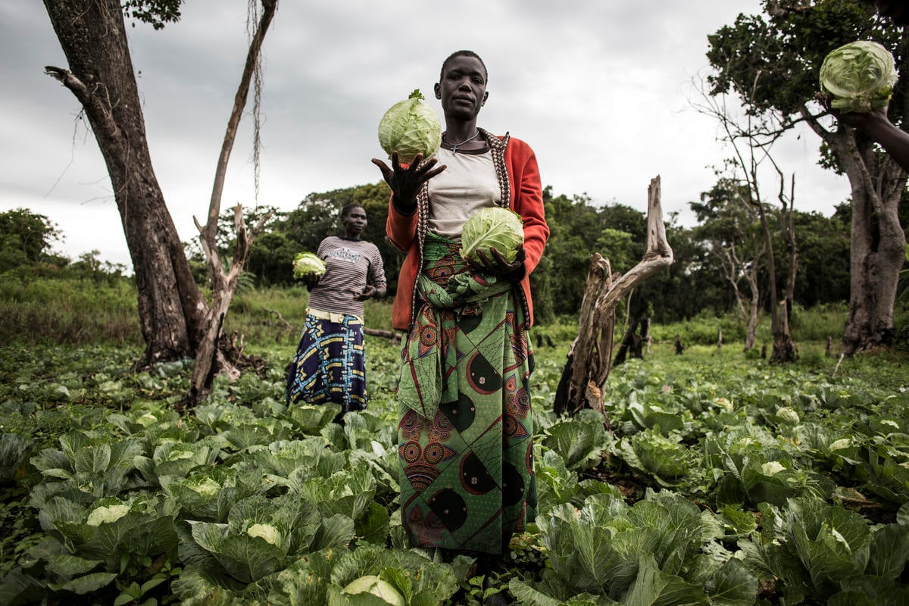
Carlinda Lopes in Biringi settlement, Democratic Republic of the Congo
26 November 2019: Farming together, refugees and their hosts reap benefits

Task
As a secretary to the Resident District Commissioner, write an essay about what your boss should communicate.
- The Kasese Peace Network Group is organising a workshop focusing on the enduring tensions between the Rwenzururu kingdom's authorities and the Ugandan government. These tensions culminated into a violent confrontation in 2016 between the Uganda People’s Defence Forces (UPDF) and the kingdom's royal guards. The government accused the royal guards of forming a militia and engaging in rebellion, prompting a military operation to dismantle the alleged militia. Despite their efforts, the organizers have failed to identify alternative actions that the kingdom’s royal guards could have taken.

Support material
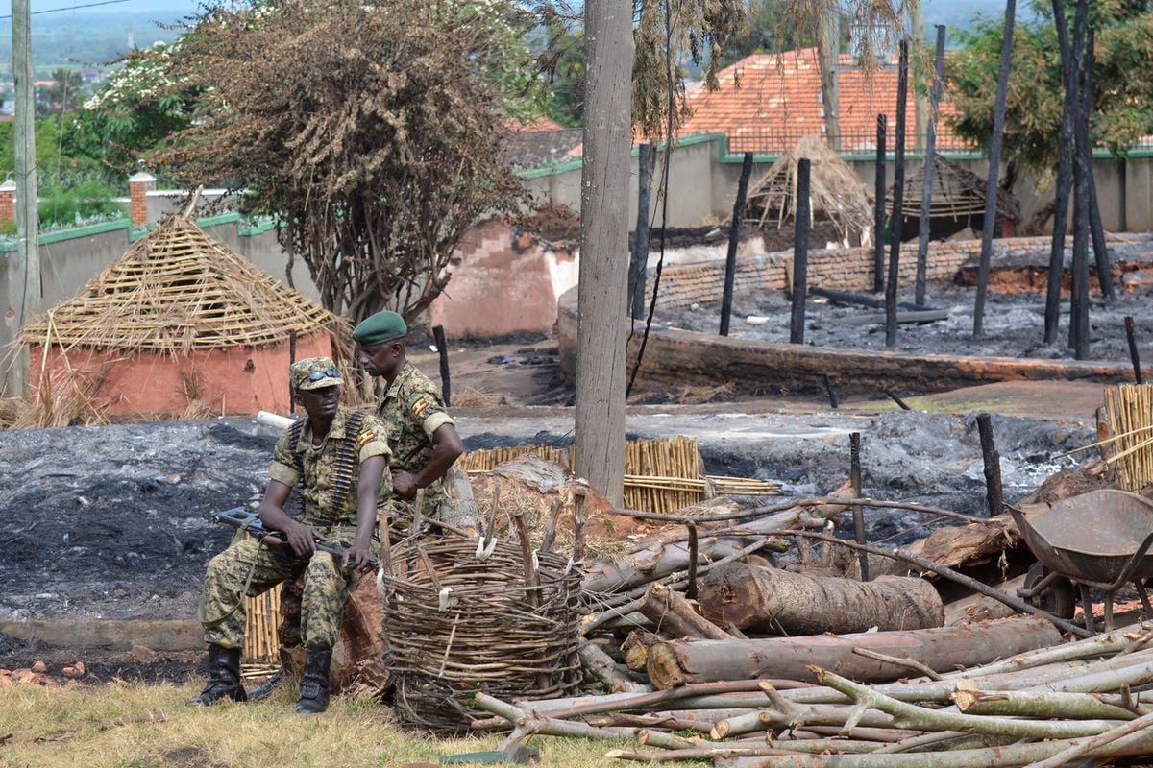
Monitor, Saturday, November 27, 2021
Task
As a knowledgeable community member, give guidance to the organizers about the ways that would have been taken by the royal guards.
SECTION B
Answer one item in this section
- A parliamentary land commission on a fact-finding mission in one of the regions in Uganda has discovered that the massive human suffering in the region results from local leaders not respecting the local laws that govern property ownership. As a native of the region, the Non-Governmental Organisation Forum has contacted you to prepare a detailed presentation to the parliamentary commission on how to improve living conditions of the locals through effective land usage.
Support material
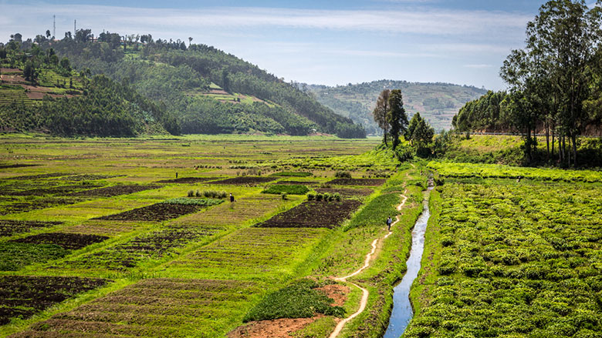
World Bank Group, June 06th 2017: A Tool for Sustainable Land Use Management in Rwanda
Task:
In an essay, write your presentation
- In a recent parliamentary session, there was a debate on the importance of fostering regional integration, cultural exchange and foreign investment. While some members emphasized the benefits of collaboration for economic growth, others expressed concerns about preserving national identity amidst interconnectedness, interdependence and potential exploitation. However, the parliamentarians failed to reach a consensus, and the speaker abstained from taking a position on the issue.
Support material

GT: The New Economic “Autarchy” November 30th 2023: A Few Fundamental Global Trends and Important Expectations.
Task:
In a detailed essay, convince the speaker to take a stand.

IF YOU NEED A SCORING GUIDE, INBOX THE ITEMS WRITER,
BAGUMA SSENTAMU RICHARD
0750025446/0784114269

